1. Print all lines containing the string San.

grep ‘San’ datebook

Grep is some kind of software tool to look for strings and numbers. In this case, we are looking for the string “San”.

1. Print all lines where the person's first name starts with J.

grep ‘^J’ datebook

^ is used to start the string from the beginning of the line.

1. Print all lines ending in 700.

grep ‘700$’ datebook



$ is used to start the string from the end of the line.

1. Print all lines that do not contain 834.

grep -v -e ‘834’ datebook

-v only shows the lines that do not match.

1. Print all lines where birthdays are in January.

grep -E ‘:01\/’ datebook

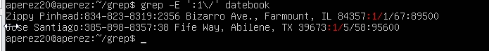

The 01 in the command is January.

1. Print all lines where the phone number is in the 408 area code.

grep -E ':408-[0-9]{3}-[0-9]{4}:' datebook

We use the [0-9] command to make sure that the 408 which is the area code is in the format.

1. Print all lines containing an uppercase letter, followed by four lowercase letters, a comma, a space, and one uppercase letter.

grep '[A-Z][a-z]\{4\}, [A-Z]' datebook

We use the command [A-Z] to print capital letters and [a-z] for lower case letters.

1. Print lines where the last name begins with k or , s or S .

grep -e '\<.\*\>[\t ]\<(K|s|S)' datebook

\< is the beginning of the word that matches with the first letter of the word and \> is the end of the word that matches with the last letter of the word. For some reason when I use the command, it works but it doesn’t show anything even with -E so I don’t know what to do

1. Print lines preceded by a line number where the salary is a six-figure number.

grep '[0-9]\{6\}$' datebook

We use 6 in the command and the end of line anchor to get the print result.

1. Print lines containing Lincoln or lincoln (remember that grep is insensitive to case).

grep -e '(L|l)incoln' datebook

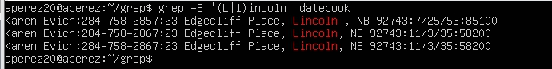

This command acts like a Boolean so therefore it will print both Lincoln and lincoln.